**User Guide – Validation Pipeline**

Contents

1. Purpose 2

2. Phases 2

3. manifest.zip 2

4. config.yml 2

5. Steps for Execution 3

## 1. Purpose

This user manual can be used as a step by step guide to use the pipeline for validating the cloud formation templates for syntax errors and security vulnerebilities, the resources contained in the templates can cause upon creation.

## 2. Phases

The pipeline has the below four stages for now:

1. Source – This is the S3 bucket where all the templates needs to be uploaded in a zipped file. The format of the zipped file is defined in section **3. maniest.zip**
2. Validate_Template – At this stage the zipped file is read and the templates are validated using cf-validator.
3. Lint_Template – At this stage the templates are validates using cfn-nag
4. Generate_report – At this stage, upon successful validation an email for success is triggered.

A failure notification will be send if the pipeline execution fails at any of the above stages.

## 3. manifest.zip

The manifest.zip is a zipped file having below folder structure:

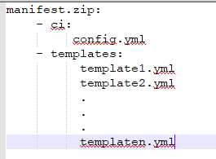

Manifest. Zip contains two folders:

1. ci: This folder contains the configuration file config.yml
2. templates: This folder contains all the templates that needs to be validated.

## 4. config.yml

The config.yml is the configuration file where we need to configure the templates for validation. The templates which are not configured in this file will not be taken up for validation.

The structure of this file is as below:

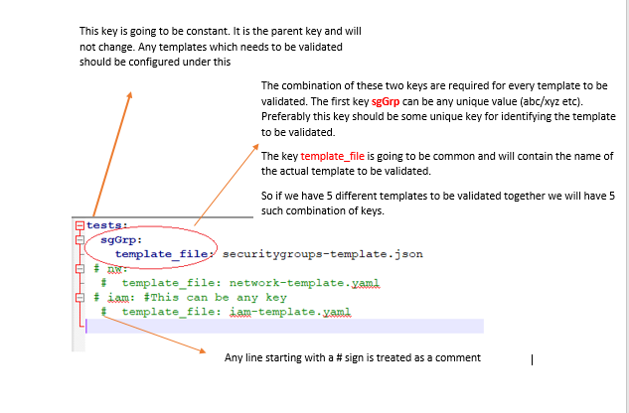

## 5. Steps for Execution

1. Go to Aws Management Console and login with account credentials in which Codepipeline is built.

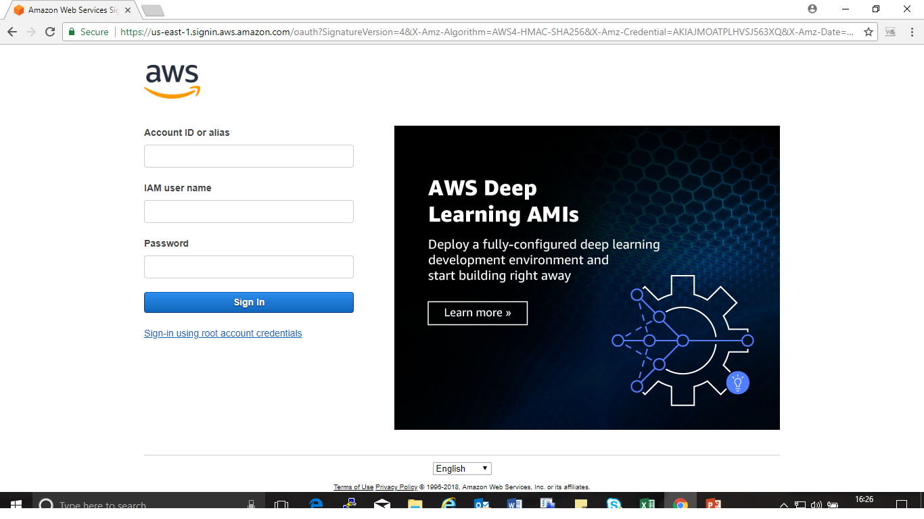

1. On the top search bar type “Codepipeline” and Click on it to open the service.

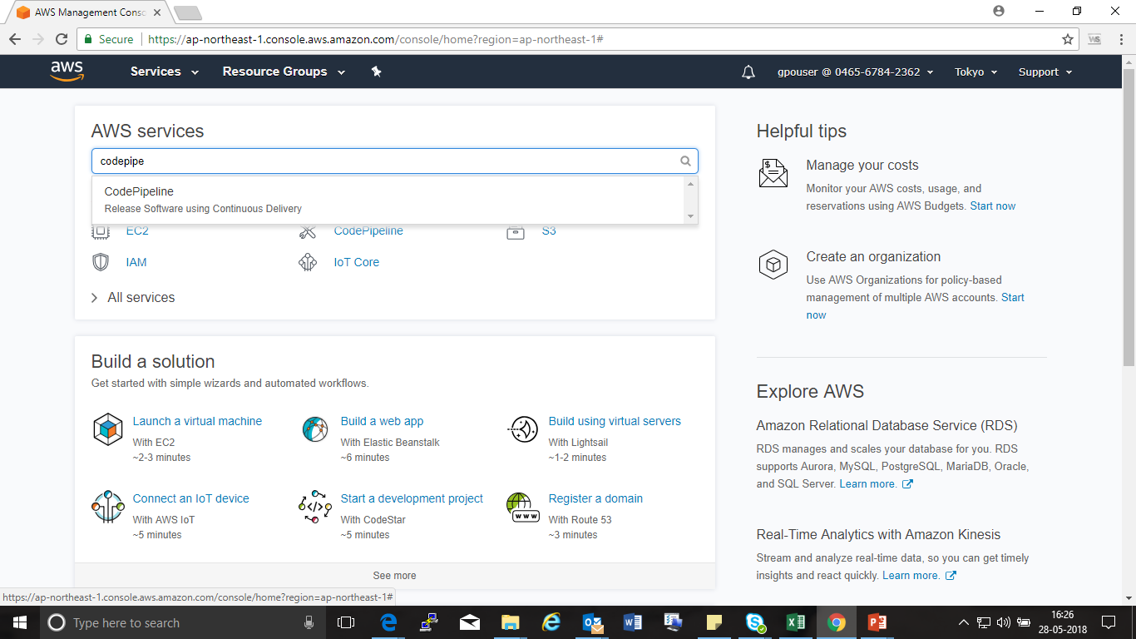

1. Now that we have access to the service click on the Pipeline already built

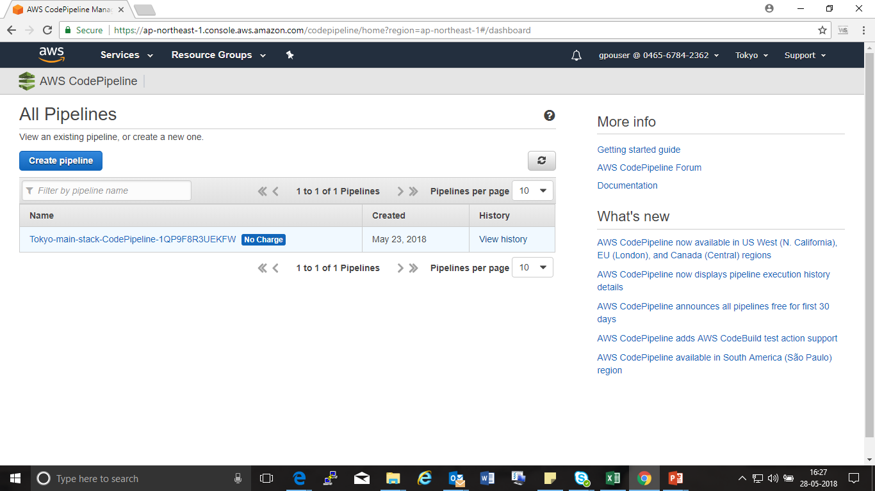

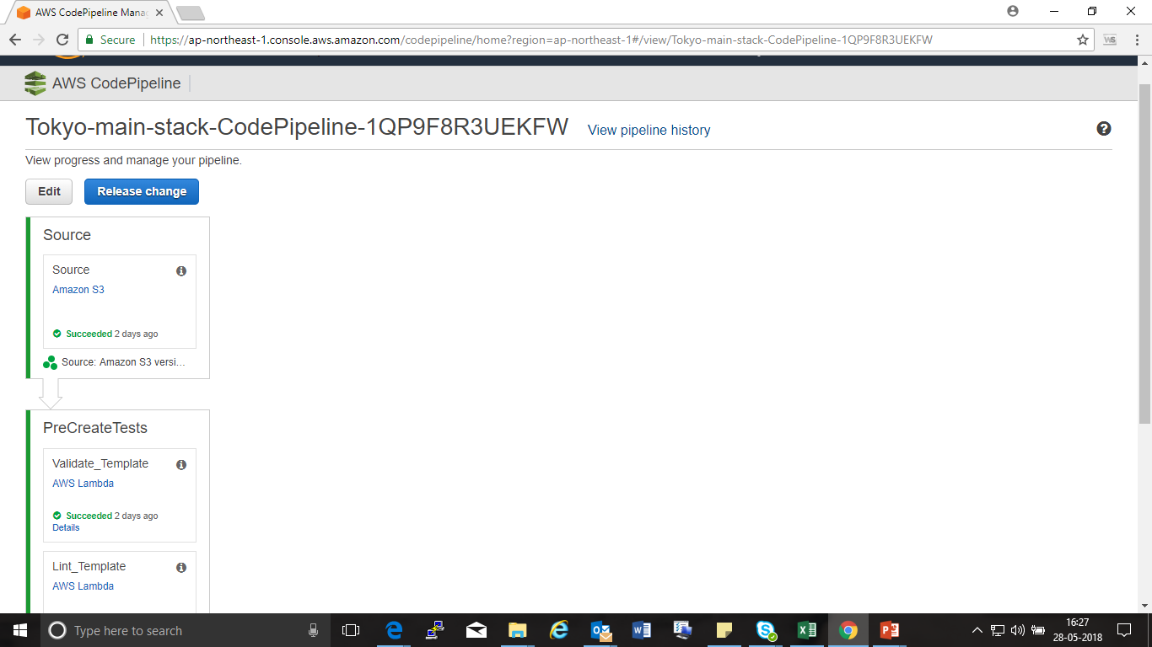4. Now we can see the flow of the pipeline as following.

5. Click on “i” icon to know the name of the S3 bucket in which the CFN-Template those have to be validated has to be uploaded.

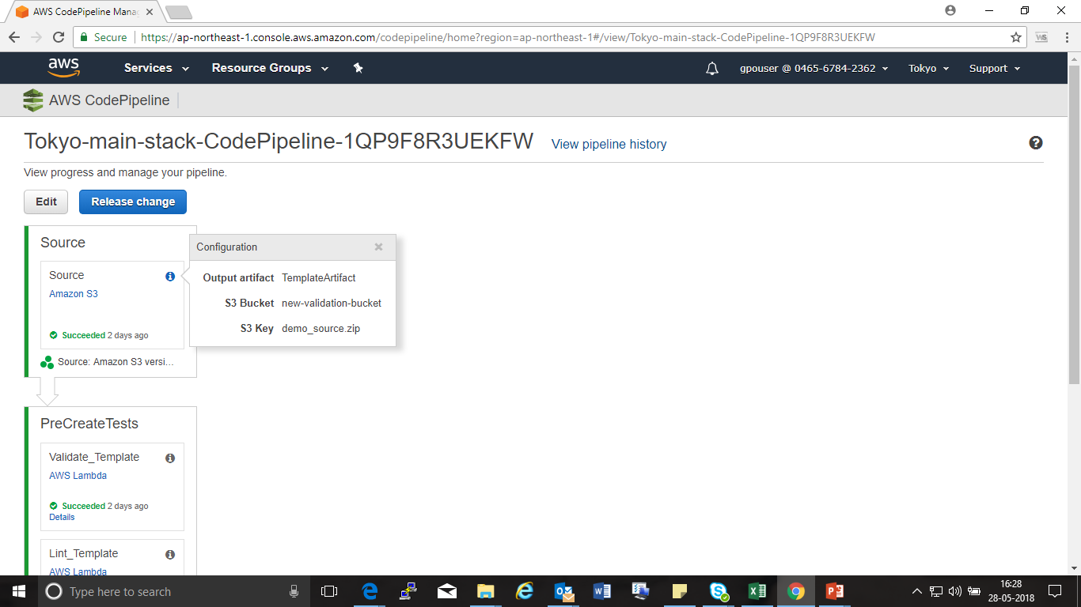

6.Now search for “S3” in the in the search bar to open S3 service.

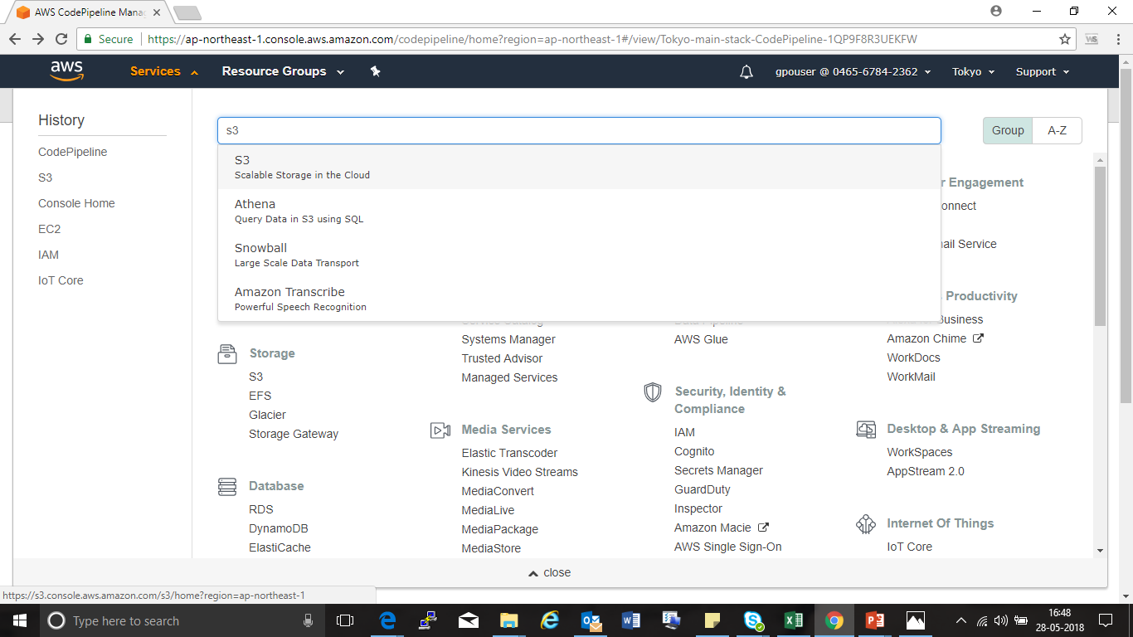

7.Now we see all the buckets as bellow.

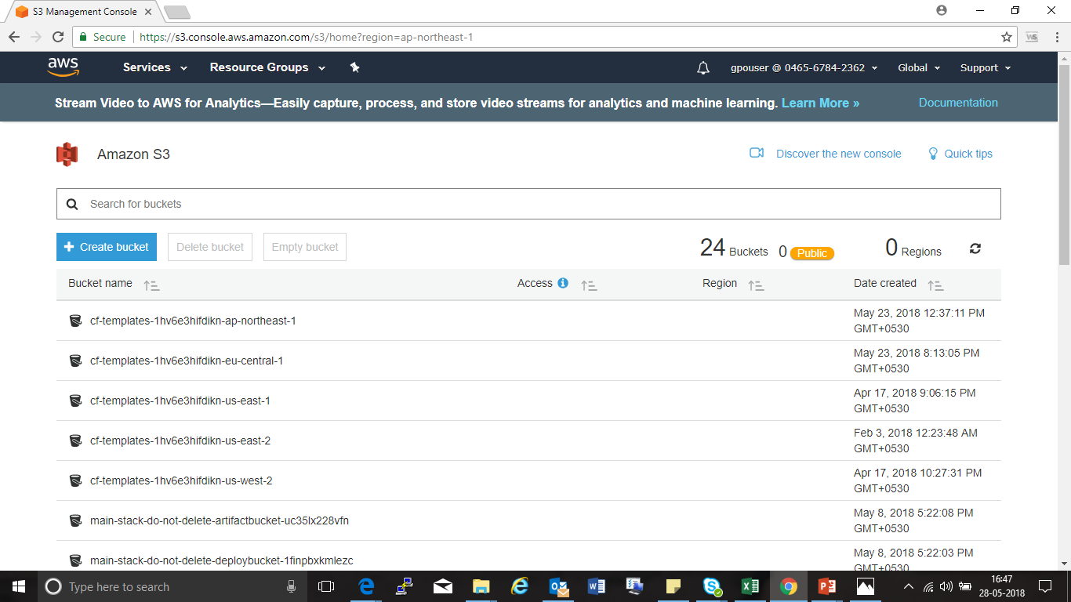

8.Now search for the bucket name as observed in Step 5.

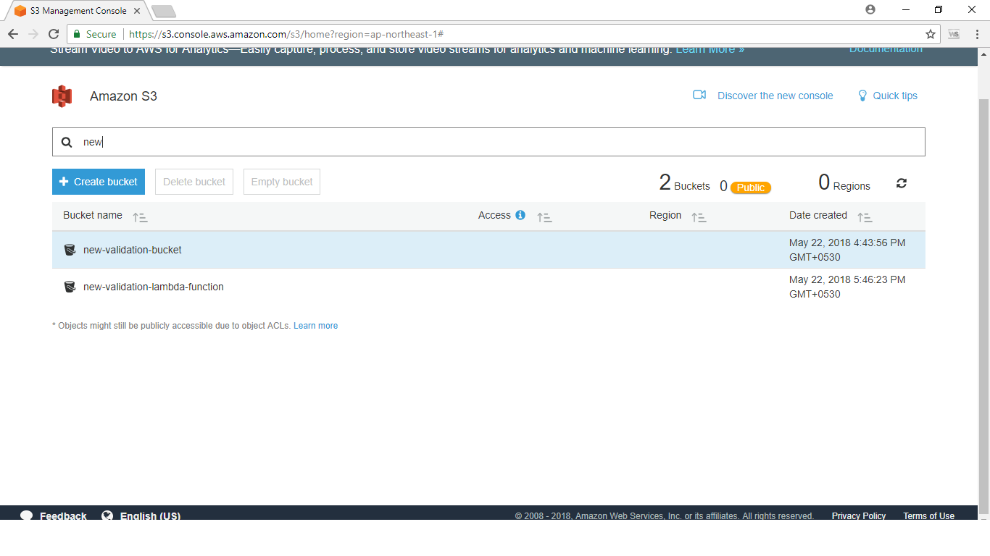

9. Now open the bucket and click on upload.

10. Upload the Zip file according to the following format specified above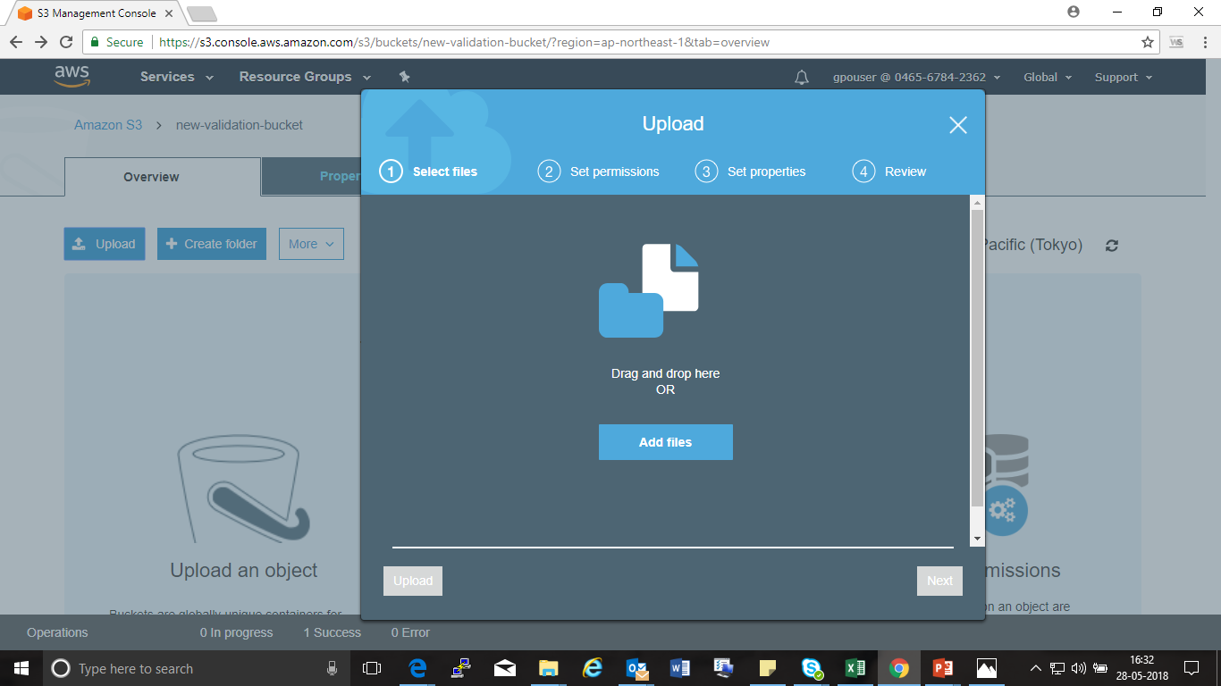

11. As soon as the ZIP file is uploaded the “CODEPIPELINE” is triggered.

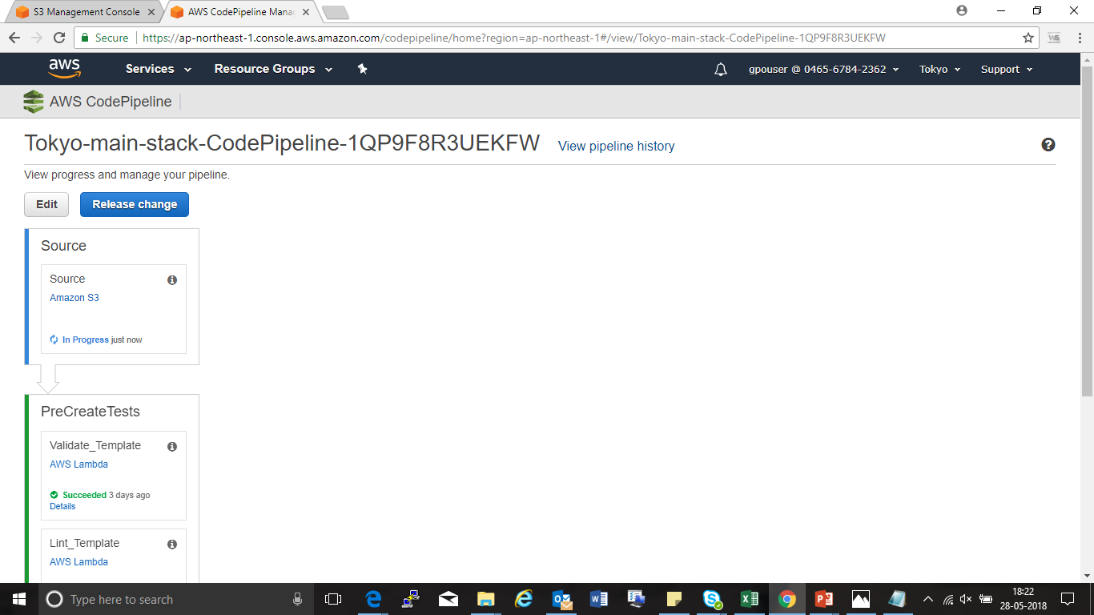

12. After all the step are executed user get Notified via an email.